**Ben Ghirardani PDA**

**Unit Analysis & Design**

A & D 1 - A Use Case Diagram

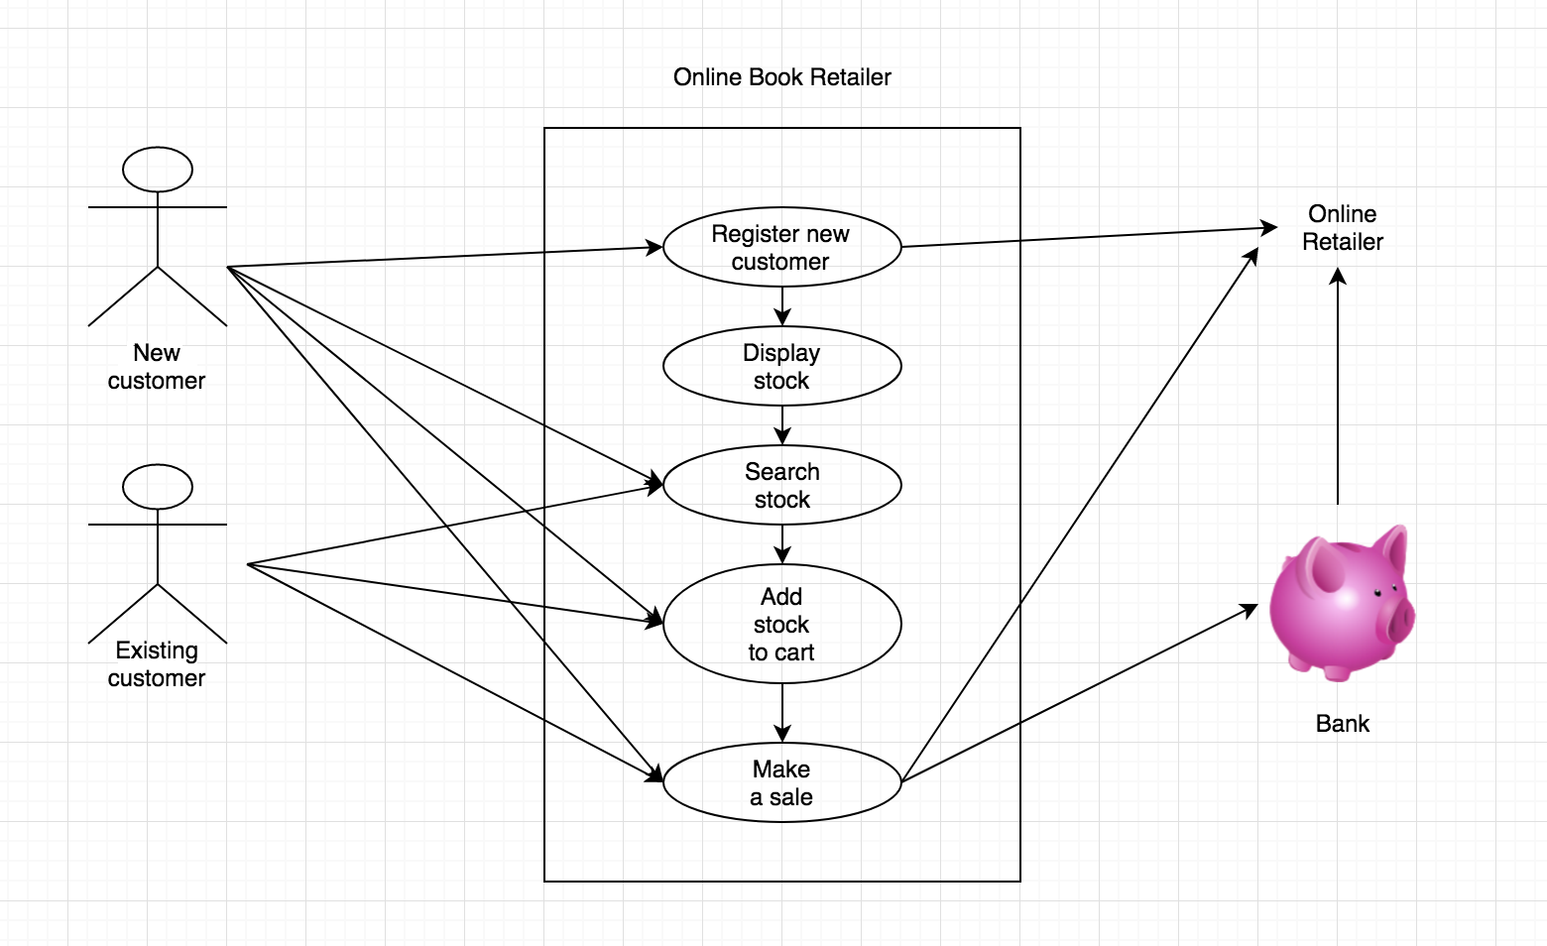

A & D 2 - A Class Diagram

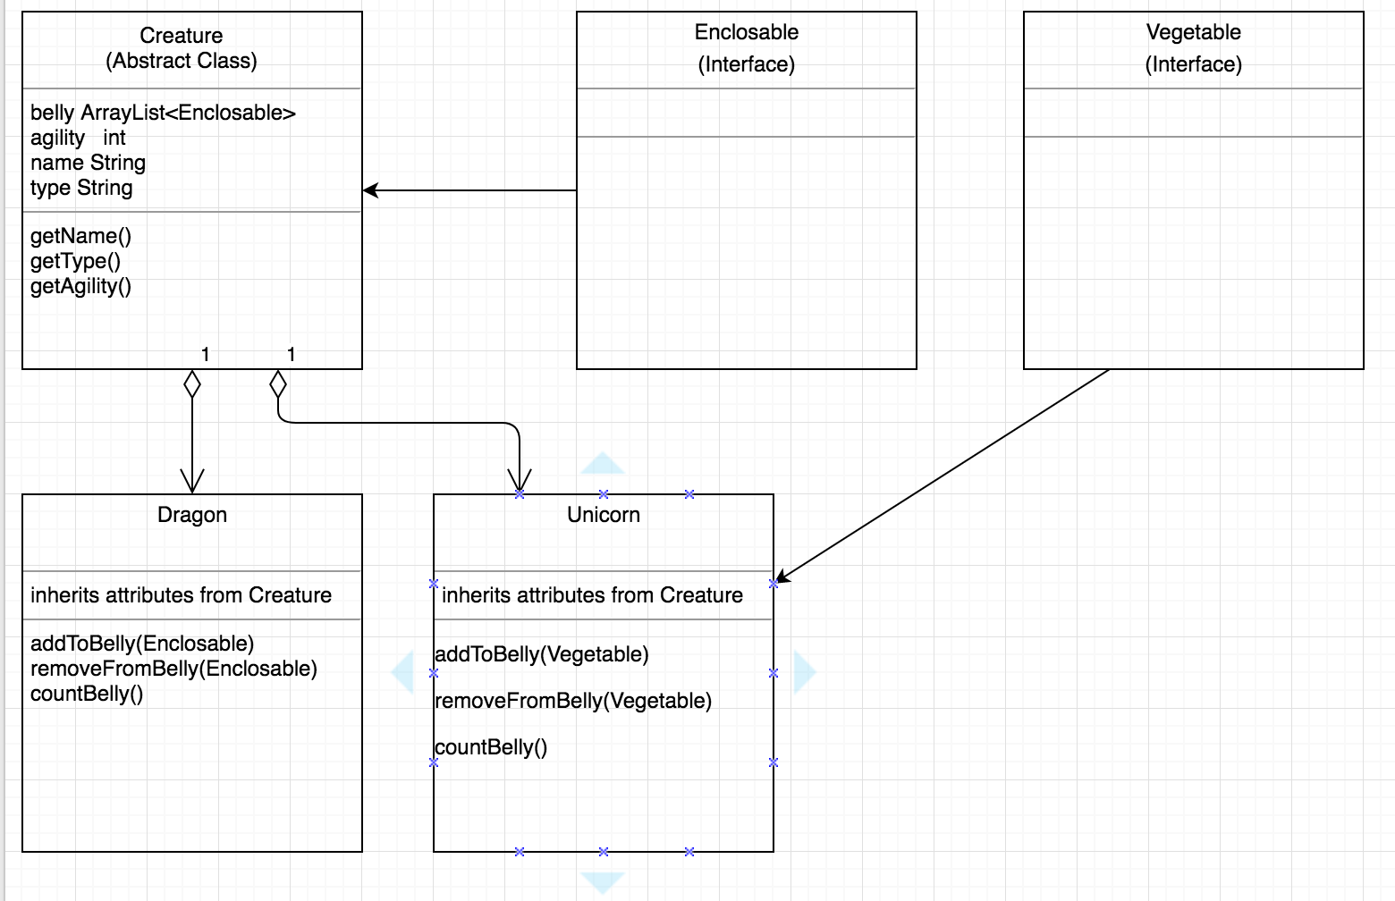

A & D 3 - An Object Diagram



A & D 4 - An Activity Diagram

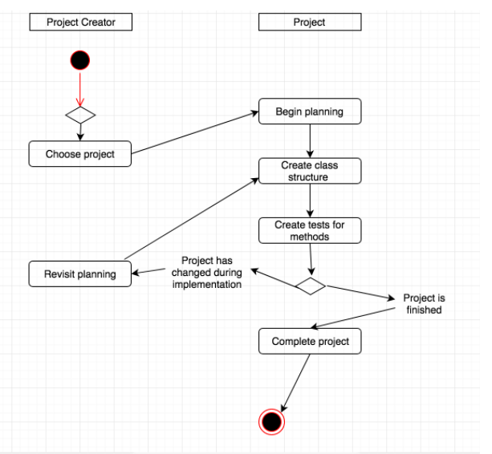

A & D 6 - Produce an Implementations Constraints plan detailing the following factors:

Plan for record store stock keeping app.

|  |  |  |
| --- | --- | --- |
| **Constraint** | **Possible Effect of Constraint on Product** | **Solution** |
| Hardware and software platforms | App is designed only for desktop/laptop screens, would not work on a mobile phone screen. | Redesign app to function on a mobile screen. |
| Performance requirements | Large amount of stock saved to database could slow search down. | Remodel database relationships to be more efficient using less computing power to run. |
| Persistent storage and transactions | App requires storage of stock to be persistent. Without this it is pointless. | Create backup of data. Prevent easy deletion of data, ie. “are you sure?” rather than instant delete on button press. |
| Usability | Colour scheme needs to account for colourblind users. Some users will use screen readers. | Provide option to customize colour schemes for colourblind users. Provide semantic HTML for screen readers. |
| Budgets | Large amounts of data could incur high costs for server space. | Invest in cloud solution that scales quickly with requirements. |
| Time | Product is required immediately for stock keeping. | Provide early prototype and iterate quickly via updates. |

A & D 5 - An Inheritance Diagram

